Exploratory Data Analysis Report

Introduction:

This report explains the exploratory data analysis (EDA) done on the e-commerce sales data. The goal was to understand the data's structure and quality, clean it where needed, and find patterns in pricing, order numbers, payment methods, and product types.

Dataset Overview:
The dataset was loaded from an Excel file and contains the following structure:
Attribute | Value
Number of rows | 1,200
Number of columns | 14
Data types | 1 datetime, 2 float, 2 integer, 9 object (categorical/text)

Columns present in the dataset:
OrderID, Date, CustomerID, Product, Quantity, UnitPrice, ShippingAddress, PaymentMethod, OrderStatus, TrackingNumber, ItemsInCart, CouponCode, ReferralSource, TotalPrice

Data Cleaning:

1. Only the CouponCode column had missing data (309 out of 1,200 rows, about 26%). Instead of removing these rows, they were labeled "No Coupon," since a blank just means no coupon was used.

2. We checked if TotalPrice matched Quantity × UnitPrice, and after rounding, everything matched perfectly — so the pricing data is accurate.

3. The Date column was reformatted into a standard YYYY-MM-DD format to keep it consistent.

4. There are 1,189 unique customers for 1,200 orders, meaning most customers bought only once, with very few repeat buyers.

Descriptive Statistics:
Summary statistics for the key numerical fields:
Statistic | Quantity | UnitPrice | ItemsInCart | TotalPrice
Mean | 2.95 | 356.41 | 5.49 | 1,053.97
Std. Dev. | 1.41 | 197.18 | 2.28 | 819.86
Min | 1 | 11.39 | 1 | 11.39
25% | 2 | 186.06 | 4 | 410.52
Median (50%) | 3 | 364.21 | 5 | 823.62
75% | 4 | 521.57 | 7 | 1,578.48
Max | 5 | 699.93 | 10 | 3,456.40

Data Distribution

Histograms:

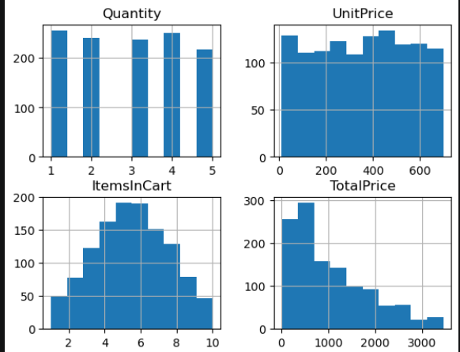

1.Order quantity is spread fairly evenly between 1 and 5 units, with no clear pattern favoring any number.

2. Item prices range widely from about ₹11 to ₹700, with no single price range being the most common.

Boxplot / Outliers:

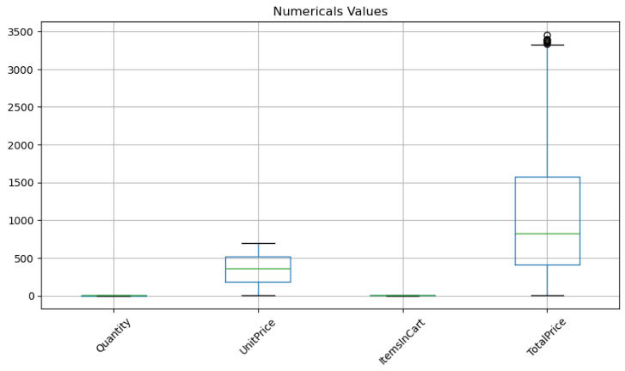

1. TotalPrice varies the most out of all four fields, and there's one unusually high order worth about ₹3,500.

2. UnitPrice varies moderately and evenly, with no unusually high or low values.

Barplot:

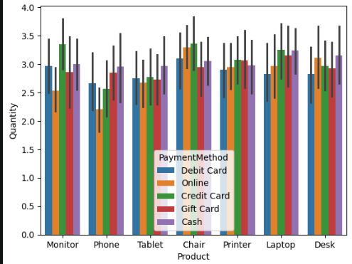

Chair and Laptop have the highest average quantity sold, while Phone has the lowest average quantity among all products.

The average quantity sold is similar across different payment methods, indicating that the payment method does not significantly affect the number of products purchased.

Orders by Product
Product | Order Count
Printer | 181
Tablet | 179
Chair | 178
Desk | 178
Laptop | 173
Monitor | 163
Phone | 156
Orders are spread fairly evenly across all seven products, with each getting between 156 and 181 orders. Printers and Tablets sell slightly more, while Phones sell the least. But the difference is small (less than 30 orders), so no product clearly outsells the rest.

Orders by Payment Method:
Payment Method | Order Count
Online | 258
Cash | 246
Credit Card | 234
Debit Card | 232
Gift Card | 230

Online payment is the most common method (258 orders, ~21.5%), followed closely by Cash. All five payment methods are used fairly evenly, indicating customers do not strongly favor one channel over another.

6.3 Quantity by Product and Payment Method
AA bar chart comparing average quantity bought for each product and payment method shows similar results across the board — mostly between 2.5 and 3.5 units. No specific product or payment method leads to noticeably higher or lower quantities, meaning how much people buy doesn't depend on the product type or how they pay.

Correlation Analysis:
Correlation matrix for the numerical fields UnitPrice, ItemsInCart, Quantity, and TotalPrice:
 | UnitPrice | ItemsInCart | Quantity | TotalPrice
UnitPrice | 1.00 | 0.00 | 0.02 | 0.72
ItemsInCart | 0.00 | 1.00 | 0.65 | 0.39
Quantity | 0.02 | 0.65 | 1.00 | 0.62
TotalPrice | 0.72 | 0.39 | 0.62 | 1.00

Key Insights
- The data is clean and accurate. Prices match up correctly, and the only missing info (CouponCode) was easy to fill in with a sensible default.
- Sales are spread out evenly across products and payment types. No single product or payment method stands out, which shows customers have varied preferences.
- Order value depends mostly on the price of the item, not how many were bought. Most orders are lower in value, but there are a few high-value orders too.

